A PROJECT REPORT
ON
“TRANSPORTATION SERVICES WEBSITE”

Submitted in fulfillment for the award of the Degree of
Bachelor of Computer Application

(2022-2023)

Submitted By

Sumit Bind (ECC2014012)
Yogesh Kumar Pandey (ECC2014001)

BCA 5th Semester



PROJECT ADVISOR
Miss. DEEPALI MISHRA
DEPARTMENT OF COMPUTERS (BCA)
EWING CHRISTIAN COLLEGE, PRAYAGRAJ.

DEPARTMENT OF COMPUTERS
[BACHELOR OF COMPUTER APPLICATION]

EWING CHRISTIAN COLLEGE
(An Autonomous Constituent P.G. College of University of Allahabad)

Certificate

This is to certify that the project entitled “Transportation Services Website” is a record work done by Sumit Bind (ECC2014012) and Yogesh Kumar Pandey (ECC2014001) in the fulfillment of the requirement for the award of the degree of Bachelor of Computer Application, Ewing Christian College, Prayagraj.

Project Advisor Evaluation Signature

Miss. Deepali Mishra Satisfactory/Unsatisfactory __________

ACKNOWLEDGEMENT

The success and outcome of this project required a lot of guidance from many people and we are extremely fortunate to have got this all along the completion of our project work. Whatever we are able to do is because of their guidance.
We would like to express our sincere thanks to our respected course coordinator Dr. Anil Kumar Singh for giving us an opportunity to work in this project.
We would also like to thank our guide Miss. Deepali Mishra, without whose guidance this project would not be a success. Finally, we would like to show our sincere gratitude to all our teachers, friends and our family members who have helped us directly or indirectly in every means to complete this project.

Sumit Bind (ECC2014012)
Yogesh Kumar Pandey
(ECC2014001)
CONTENT

Chapter 1. Introduction…………………………………...……...…. 5
Chapter 2. Objective and Scope of the project……………………… 6
Chapter 3. Synopsis of the project……………………………......… 7
3.1 Features of the Project
3.2 Objective of the Project
Chapter 4. About the project………………………………………... 8
4.1 Advantages of the Project
4.2 Disadvantages of the Project
4.3 Limitations of the Project
Chapter 5. Theoretical Background………………………………… 9
5.1 Who are Packers and Movers
Chapter 6. Technologies Used……………………………………... 10
6.1 About Visual Studio Code
6.2 About React.js
6.3 Styled-Components
Chapter 7. Analysis……………….................................................... 16
7.1 System Analysis
7.2 Problem Analysis
Chapter 8. Feasibility Study…………………………………………18
8.1 Technical Feasibilities
8.2 Economic Feasibilities
8.3 Operational Feasibilities
Chapter 9. Requirement Specification……………………….…….. 20
9.1 Requirement Specification
9.2 Purpose
9.3 Objective
9.4 Scope
9.5 Hardware Requirements
9.6 Software Requirements
Chapter 10. Diagrams……………………………………………….23
10.1 User Flow Chart
10.2 User Case Diagram
Chapter 11. Development Methodology………………………….... 25
Chapter 12. Implementation………………………………………... 26
12.1 User Training
12.2 User Manual
12.3Conversion
Chapter 13. Activity Chart………………………..………………... 28
Chapter 14. Input/Output Screen Design………………………..…. 29
Chapter 15. Coding………………………………..……………….. 34
Chapter 16. Future Scope of the Project……………..…………….. 44
Chapter 17. Conclusion………………………………………..….…45
Chapter 18. References…………………………………………….. 46

CHAPTER 1: INTRODUCTION

In the present time, people, generally in major cities in India, keep moving from one place to another within the city or to different cities. While moving they all often face a common problem of packing and moving their belongings. This makes it inconvenient for them. Packers and Movers, a category of Indian Logistics sector is there to tackle this problem.

Moving cities might be one of the hardest things you might have to deal with, especially if you are doing it alone and you are not familiar with the place you are moving to. This comes along with a pool of obstacles that is traumatic and also time-consuming. One has to be prepared for this in advance only then he/she can have an easy, safe and smooth relocation experience. “Packers AND Movers “is a Transportation Management Website used for the Transportation for the Users of their Orders. In this Project User Creation, District Code Generation, Location Code Generation, Employee Details, Driver Details, Orders Placed. PACKERS AND MOVERS are service providers that pack and move your belongings including furniture, suitcases, artefacts, and furnishings, among others safely. This helps to ease out the moving process as these service providers become our one-stop shop for relocating solutions. Damage-free relocation is a big concern. PACKERS AND MOVERS provides you professional support to relocate your precious goods in a systematic and planned manner they had shortlisted few of its best professional vendors who are just a call away whether you want to shift Vehicle or office or households,

This project too is based on a Packers Movers company that is currently operating from Bangalore and is providing its services majorly across South Indian states. This project has been built keeping in mind the importance of simplicity of GUI. Efforts have been made to make the platform user-friendly.
CHAPTER 2: OBJECTIVE AND SCOPE OF THE PROJECT

The main objective of this project is to provide the company an online platform. And since this platform will minimize the market gap between the service-provider and the customer, it will be beneficial for both, the company involved and the customer who is looking for a trustable service-provider.
This project will also minimize the efforts of both the individuals involved. It will eliminate the need for person-to-person network for seeking the required services. We can also say this platform will eliminate the traditional methods.

- The platform contains all the necessary information that the customers need to identify the existence of the service-provider.
- Currently project contains 4 pages.
- The home page of the website welcomes the end-user and is rendering some components from other pages too.
- Home page also displays the services they can get currently from the platform.
- It also contains an embedded map that shows the office location in the city.

CHAPTER 3: SYNOPSIS OF THE PROJECT

This project is being built for a Packer and Mover company that currently lacks the online presence. This is a project for the company involved in packing and moving of goods, vehicles, electric appliances etc. Due to its absence digitally despite the whole market is dealing with internet things, they had limited reach.

Without proper website, companies much time was spent dealing and marketing in offline modes by mediums such as visiting cards, posters, person to person network etc.
As happens in market, without knowing about the confidentiality of services or product of any company, any customer will not show any interest towards it. This project was chosen to tackle this problem. The website will contain all the necessary details about the confidentiality of the company.

The website will provide an interface between the customer and the service providers. The website will allow the costumer to get in touch with the personnel attached to the respective service provider.

3.1 Features of the project:

This project aims to develop a website for the company and provide a way to the users or customers to directly get in touch to the company’s employees.
The project has the following features-
- Easy to use website with all the necessary details provided keeping things as simple as they can be.
- Allows users to investigate throughout the website to ensure the confidentiality of the service-provider.
- User can send data through a working form.
- The data will be received at the service-providers end through which they can contact the user later.

3.2 Objective of the project:

The overall objective of this project is to eliminate all the problems that the company was facing earlier due to absence of their own website.

The problems can be defined in the following ways-

- MARKET GAP – Lack of digital presence makes customers doubtful
- CUSTOMERS – It takes lots of effort to prove your confidentiality to customers
- FINANCIALS – Third-Party listings aren’t cost-effective, even after providing your services you may not gain too much
- ADVERTISEMENT – You can advertise your website too. Offline marketing do not provide enough to grow
CHAPTER 4: ABOUT THE PROJECT

This project is the practical implementation or we can say that an attempt to tackle the above mention problems. The website has been developed only after studying the platforms of other competitors of the same industry. While this project might eliminate the major problems discussed before in the report there are still many more to tackle.

4.1 Advantage of the project:
- After this project, the problem of Market Gap will be solved.
- Needy customers can be targeted easily using this platform.
- Not relying on third-party will reduce expenses drastically.

4.2 Disadvantage of the project:
- Since the project is built using latest technologies, maintenance charges may incur in future.
- Currently there is no or default form validation, so spam data can be sent easily.

4.3 Limitations of the project:
- Only 1000 forms submissions can be done per month as that of now.
- Call button still not working as intended.

CHAPTER 5: THEORETICAL BACKGROUND

We live in a modern world where we can get everything in an easy and fast way. We can order food for our house and as well as we can see our beloved one who lives in the United States. But these advanced technologies and modern solutions are not enough to get rid of the trouble we face in our daily lives. Shifting a house or office from one place to another is a major issue in our daily life for those who want to shift. A complete house relocation process includes many risks and worries, from managing your packing to loading, unloading, transporting, etc. And to prevent those obstacles, people are looking for a service that will take care of all of their worries. Packers and movers are born and provide their best services in house or office shifting to solve these issues. If you are confused about what is packers and movers? How will they work? How will they help you with house shifting? You must read this complete article. We covered all the necessary key points of the packers and movers’ industry

5.1 Who are Packers and Movers:

Packers and movers are companies responsible for your house, office, vehicle, pets, plants, etc., relocation. They will cover a-z packing and moving services like packing, loading, transporting, unloading, unpacking, etc. They can carry your entire house or office without giving you any trouble or headache.
Many of us seeking job or business opportunities often change our careers and businesses to different locations. We are always afraid of completing the whole shifting process when shifting households. We all have that fear of losing or breaking goods, and the important part is we are frustrated by thinking stampede and tension that comes in the way of moving.
To solve these issues, packers and the moving industry were born. They will take care of all of your worries and tensions in the shifting. Packers and movers handle your entire relocation process by providing end-to-end services of your households shifting. And these services can help to get utterly hassle-free relocation with a minimalist period. Let us know about the types of packers and movers and which one is perfect for your relocation

CHAPTER 6: TECHNOLOGIES USED

IDE used: Visual Studio Code
LANGUAGES: JavaScript, React.js (library of JavaScript) , Styled-Components

6.1 About Visual Studio Code:

Visual Studio Code is a code editor in layman’s terms. Visual Studio Code is “a free-editor that helps the programmer write code, helps in debugging and corrects the code using the intelli-sense method”. In normal terms, it facilitates users to write the code in an easy manner. Many people say that it is half of an IDE and an editor, but the decision is up to to the coders. Any program/software that we see or use works on the code that runs in the background. Traditionally coding was used to do in the traditional editors or even in the basic editors like notepad! These editors used to provide basic support to the coders.

Some of them were so basic that it was very difficult in writing basic English level programs in them. As time went by, some programming languages needed a specific framework and support for further coding and development it, which was not possible using these editors. VI Editor, Sublime Text Editor, is one of the many kinds of editors that came into existence. The most prominent and which supports almost every coding language is VISUAL STUDIO CODE.
Its features let the user modify the editor as per the usage, which means the user can download the libraries from the internet and integrate it with the code as per his requirements.

6.2 ABOUT REACT.JS

The world cannot live without mobile and web applications currently. Everything is digitized, from booking cabs to ordering food to make bank transactions. Thanks to the efficient frameworks that provide a seamless user experience. One such robust frontend library is React.

6.2.1 Overview of React.js:

React is a JavaScript-based UI development library. Facebook and an open-source developer community run it. Although react is a library rather than a language, it is widely used in web development. The library first appeared in May 2013 and is now one of the most used frontend libraries for web development.
React offers various extensions for entire application architectural support, such as Flux and React Native, beyond mere UI.

6.2.2 Features of React.js:

Easy creation of dynamic applications:
React makes it easier to create dynamic web applications because it requires less coding and offers more functionality, as opposed to JavaScript, where coding often gets complex very quickly.

Improved performance:
React uses Virtual DOM, thereby creating web applications faster. Virtual DOM compares the components’ previous states and updates only the items in the Real DOM that were changed, instead of updating all of the components again, as conventional web applications do.

Reusable components:
Components are the building blocks of any React application, and a single app usually consists of multiple components. These components have their logic and controls, and they can be reused throughout the application, which in turn dramatically reduces the application’s development time.

Unidirectional data flow:
React follows a unidirectional data flow. This means that when designing a React app, developers often nest child components within parent components. Since the data flows in a single direction, it becomes easier to debug errors and know where a problem occurs in an application at the moment in question.

Small learning curve:
React is easy to learn, as it mostly combines basic HTML and JavaScript concepts with some beneficial additions. Still, as is the case with other tools and frameworks, you have to spend some time to get a proper understanding of Reacts library.

It can be used for the development of both web and mobile apps:
We already know that React is used for the development of web applications, but that’s not all it can do. There is a framework called React Native, derived from React itself, that is hugely popular and is used for creating beautiful mobile applications. So, react can be used for making both web and mobile applications.

Dedicated tools for easy debugging:
Facebook have released a Chrome extension that can be used to debug React applications. This makes the process of debugging React web applications faster and easier.

6.2.3 JSX in React.js:

JSX is a JavaScript syntactic extension. It is a term used in React to describe how the user interface should seem. You can write HTML structures in the same file as JavaScript code by utilizing JSX.



6.2.4 Virtual Document Object Model:

The Virtual DOM is React's lightweight version of the Real DOM. Real DOM manipulation is substantially slower than virtual DOM manipulation. When an object's state changes, Virtual DOM updates only that object in the real DOM rather than all of them.
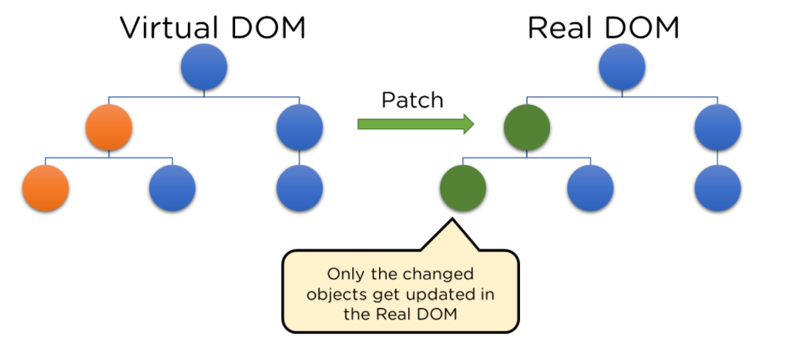

6.2.5 What is Document object Model:

DOM (Document Object Model) treats an XML or HTML document as a tree structure in which each node is an object representing a part of the document.
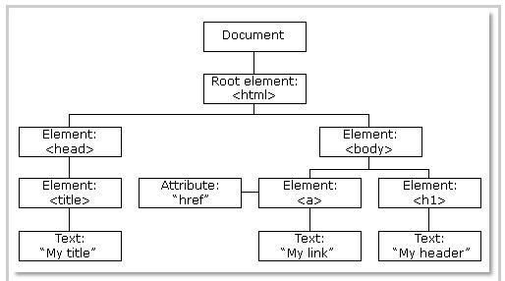

6.2.6 Data Binding:

Since React employs one-way data binding, all activities stay modular and quick. Moreover, the unidirectional data flow means that it's common to nest child components within parent components when developing a React project.
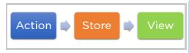

6.2.7 Advantages of React.js:
- React.js builds a customized virtual DOM. Because the JavaScript virtual DOM is quicker than the conventional DOM, this will enhance the performance of apps.
- ReactJS makes an amazing UI possible.
- Search - engine friendly ReactJS.
- Modules and valid data make larger apps easier to manage by increasing readability.
- React integrates various architectures.
- React makes the entire scripting environment process simpler.
- It makes advanced maintenance easier and boosts output.
- Guarantees quicker rendering
- The availability of a script for developing mobile apps is the best feature of React.
- ReactJS is supported by a large community.

6.3 Styled-Components:

Styled components are a CSS-in-JS tool that bridges the gap between components and styling, offering numerous features to get you up and running in styling components in a functional and reusable way.
At the core of CSS is the capability to target any HTML element — globally — no matter its position in the DOM tree. This can be a hindrance when used with components, because components demand, to a reasonable extent, colocation (i.e., keeping assets such as states and styling) closer to where they’re used (known as localization).
In Reacts own words, styled components are “visual primitives for components”, and their goal is to give us a flexible way to style components. The result is a tight coupling between components and their styles.
Note: Styled components are available both for React and React Native.

6.3.1 Features of Styled-Components:

Styled-components is the result of wondering how we could enhance CSS for styling React component systems. By focusing on a single use case, we managed to optimize the experience for developers as well as the output for end users.

- Automatic Vendor Prefixing: -
You can use standard CSS properties, and styled components will add vendor prefixes should they be needed.

- Unique Class Names: -
Styled components are independent of each other, and you do not have to worry about their names because the library handles that for you.

- Elimination Of Dead Styles: -
Styled components remove unused styles, even if they’re declared in your code.

- Automatic Critical CSS: -
styled-components keeps track of which components are rendered on a page and injects their styles and nothing else, fully automatically. Combined with code splitting, this means your users load the least amount of code necessary.

- Easier Deletion of CSS: -
It can be hard to know whether a class name is used somewhere in your codebase. styled-components makes it obvious, as every bit of styling is tied to a specific component. If the component is unused (which tooling can detect) and gets deleted, all its styles get deleted with it.

- Simple Dynamic Styling: -
adapting the styling of a component based on its props or a global theme is simple and intuitive without having to manually manage dozens of classes.
CHAPTER 7: ANALYSIS

Analysis is detailed study of various operations performed by a system and their relationships within and outside of the system. Analysis is a management technique, which helps us in designing a new system, or improvement of the existing system a key question is what must be done to solve the problem? One aspect of analysis is defining the boundaries of the system and determining the benefit of the system. During analysis, data are collected on the available files, decision points transactions handle by the present system.
Requirements analysis is the process of analyzing the information needs of the end users, the organizational environment, and any system presently being used, developing the functional requirements of a system that can meet the needs of the users.

7.1 System Analysis

Review the written documents Studying:
The existing manuals and forms we gather information regarding the existing system. There are some manuals that describe the role of each person in the share MANAGEMENT department. They keep user and shares record for the concerned persons.

7.2 On-site observation:
Observation must be carried out to gather the information about the existing system. On visiting the India bulls and Share khan office in Noida the massive information is collected about the existing system. The enormous volume of inefficiency and disorganization was there regarding to users’ expectations. Each user is dependent on the brokers.

7.3 Interview:
To know staff or officers’ perception regarding the manual system an interview is conducted. During the interview we came to know about various steps they follow in handling of shares and records of persons, what are the difficulties they face and other correspondences.

7.4 Questionnaires:
Questionnaires can be used to get information from large groups of people. Advantages of questionnaires are anonymity and evidence of trends. Various questionnaires are made to the employee or staff regarding the requirement they need. A set of question are asked to know about various necessity the desire like Hindi Subject data entry, edit the wrong entry made, listing the pending details, security to the records etc.

7.5 Problem Analysis

This project which focuses on delivering a platform for packers and movers company aims at developing a website that could provide minimal need of communication between the user and service provider. Before starting the development of project, various other similar platforms available across internet were identified and closely studied. It included what kind of services the users need and the services being provided by the different service-providers.
After the analysis, the objective was to develop a platform that could provide the details of the company and necessary data could be shared by the user to the service-provider.
- Services being provided
- Sharing of User data

Services being provided:
This was necessary in order to tell the user about the services. So that they could request needed service.

Sharing of User data:
This part was essential for identifying the user who has requested for the services.
CHAPTER 8: FEASIBILITY STUDY

The feasibility of a project can be ascertained in terms of technical factors, economic factors, or both. A feasibility study is documented with a report showing all the ramifications of the project. Preliminary investigation and need of identification analysis helps us very much in determining whether the proposed system is feasible or not. In this phase, every alternative should be defined and then each one evaluated which gave me important information about the system feasibility like:
  - What is the needed?
  - What are the availabilities?
  - What are limitations?
  - What are possibilities?
  - What is not possible?

Now there was the big question that how many types of feasibility should be considered because study of feasibility is omni directional. So, we mainly consider three types of feasibility:

- Technical Feasibility
- Economic Feasibility
- Operational Feasibility

8.1 Technical Feasibilities: -
Technical feasibility refers to the ability of the process to take advantage of the current state of the technology in pursuing further improvement. The technical capability of the personnel as well as the capability of the available technology should be considered. Technology transfer between geographical areas and cultures needs to be analyzed to understand productivity loss (or gain) due to differences. During study of technical feasibility, we mainly investigated that:
Can The Work for Project Be Done with The Current Equipment, Existing Software Technology and Available Personal?
What Are the Various Technologies Available in Present System?
Is New Technology Needed?
If Needed Then What Type of Technology Is Needed?
Is This Proposed Technology Would Be Compatible with The Present Environment?

8.2 Economic Feasibility: -
This involves the feasibility of the proposed project to generate economic benefits. A benefit-cost analysis and a breakeven analysis are important aspects of evaluating the economic feasibility of new industrial projects. During the analysis of the economic feasibility, we investigate the following points:
- About the cost of the project.
- Calculation about the effectiveness of the system.
- Cost/Benefit analysis of the proposed project.
- In Cost/Benefit analysis we compare the expected benefit of the proposed system with the cost of the proposed system, when the benefit is more than the cost of the system then we decided to design and implement the proposed system.
- This is an ongoing effort that improves in accuracy in each phase of the system life cycle.

8.3 Operational Feasibility: -

During the operational feasibility analysis, we investigate that the operating requirements of the proposed system is feasible or not. We analyze mainly is there any resistance for the proposed system related to the operating requirements? For those we consider following points:

- Is current method being acceptable to the user? If they are not, users may welcome a change about the operations of proposed system.
- Will the proposed system cause harm?
- Will it produce poorer outcome?
- Will the performance of staff member fall down after implementation?
- Issue that appears to be quite minor at the earlier stage can grow into major problem after implementation.
CHAPTER 9: REQUIREMENT SPECIFICATION

An accurate and through understanding of system requirements is essential to the success of any Software Development Process. All further stages of SDLC like system analysis, design and coding depend on how accurate well prepared and thoroughly understood the System Requirements Specification is. Poorly analyzed requirements will disappoint the user no matter how well designed and the well coded the software is.

Requirement specification appears to be a relatively simple task but the chances of misinterpretation is very high, ambiguity is probable and communication gap between user and developer is bound to bring confusions. Requirement Specifications begin with a clear and concise heading stating in a sentence the task to be performed (i.e., work objective). For this, we must identify the problem first. Problem specifications serve as the basis for identifying work objective that helps in describing the requirements in technical and precise statements. After the initial specification reports are received, they are analyzed and refined through user and developer interaction. System Analysis follows to determine feasibility and Cost Benefit Analysis.

A complete understanding of requirement specification of the new system is very important for the successful development of the software product. Requirement specification is the foundation in the process of software development. All further development like System Analysis, System Design, and Coding will depend on how accurate and well prepared the requirement.

9.1 Overall Description

Requirement specification appears to be relatively simple task, but appearances are often deceiving. There is always a chance of wrong specification because of communication gap between user and developer, ambiguity in requirement or a wrongly specified problem. Requirement Specification begins with a clear statement of the problem and the task to be performed. Then requirements are described in a technical manner in precise statements. After the initial specification reports are received, they are analyzed and refined through user developer interaction. System Analysis follows to determine and cost benefit analysis.
An SRS is basically an organization's understanding (in writing) of a customer or potential client's system requirements and dependencies at a particular point in time (usually) prior to any actual design or development work. It's a two-way insurance policy that assures that both the client and the organization understand the other's requirements from that perspective at
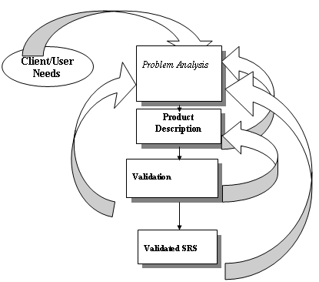
The SRS document itself states in precise and explicit language those functions and capabilities a software system (i.e., a software application, an ecommerce Web site, and so on) must provide, as well as states any required constraints by which the system must abide. The SRS also functions as a blueprint for completing a project with as little cost growth as possible. The SRS is often referred to as the "parent" document because all subsequent project management documents, such as design specifications, statements of work, software architecture specifications, testing and validation plans, and documentation plans, are related to it.
It consists following phases.
Performance Requirement
- Purpose
- Objective
- Scope
Technologies and platform used
- Overall Description
- Product Functions
- User Characteristics
Specific Requirements
- User Interfaces
- Hardware Interfaces
- Software Interfaces
- Communication Interface

User need identification and analysis are concerned with what the user needs rather than what the user wants. Not until the problem has been identified, defined and evaluated should the analyst think about solutions and whether the problem is worth solving.

9.2 Purpose: -
As an analyst we identified the following reasons for the need of the proposed system:

- Need to minimize the human efforts for searching a genuine service- provider.
- To make the packing and relocation of goods convenient.
- To come to a mutual agreement so that there is no hidden cost for the services.
- The success of the system depends largely on HOW a problem is defined.

9.3 Objective: -
Develop a packer movers website that will help to identify the service-provider and establish communication with the users.

9.4 Scope: -
If there is significant growth for the company, this project may be extended and can include features such as user--register and login features.

9.5 Hardware Requirement:

Hardware which is required to run this project is: -

Input Device: Keyboard, Mouse.
Output Device: Monitor.
Primary Memory: RAM 512MB recommended for efficient result.
Secondary Memory: Hard drive 10GB recommended.
Processor: Pentium D or above.

9.6 Software Requirement:

Software which is required to run this project: -

Platform: Any Operating System
Application SW: Any Web-Browser Supporting React
IDE: Visual Studio Code
Languages: React with Styled-Components

CHAPTER 10: DIAGRAMS

10.1 User Flow Chart:

User Visits platform

View Services

Request for Quote

Submit

10.2 User Case Diagram:

Visit Website

View Service Details

Enquire for Services

Send Request Quote

CHAPTER 11: Development Methodology

As an analyst I have chosen waterfall model for software engineering paradigm. We have chosen waterfall model because this model is best suitable on the nature of the proposed project, application, methods, tool be used and controls that are required. To solve the actual problem the analyst must incorporate a development strategy that encompasses the process.
Waterfall model suggests me a systematic, sequential approach to software development. This model begins with the system level and progress through analysis, design coding, testing and support.

In this process model we have processed the following activities:

- System/information engineering and modeling.
- Software requirements analysis.
- Design.
- Coding.
- Testing.
- Support.

Water Fall Model:

The Water Fall Model is also known as classic life model or linear sequential model. It suggests a systematic sequential approach to software development that begins at the system level and progresses through analysis, design, coding, testing and maintenance. Modeled after the conventional engineering cycle, the linear sequential model encompasses engineering cycle.

CHAPTER 12: IMPLEMENTATION

A crucial phase in system development is the successful implementation of the new system design. Implementation includes all those activities that take place to convert from the old system to the new system. The new system may be completely new replacing an existing manual or automated system or it may be major modification to an existing system.

In either case proper implementation becomes necessary so that a reliable system based on the requirement of the organization can be provided. Successful implementation may not guarantee improvement in the organization using the new system, but improper installation will prevent this improvement.

It has been observed that even the best system cannot show good results if the analysts managing the implementation do not attend every important detail. This is the area where the system analysts need to work with utmost care.

There are three main aspects of implementation: -
- User training
- User Manual
- Conversion

12.1 User Training:
Even well-designed system can succeed or fail because of the way these are operated and used. Therefore, the quality of training received by the personal involved with the system in various capacities helps or hinders and may even prevent the with the system development must know in detail what their roles will he, how they can make efficient use of the system and what they will not do for them.
An analysis of user training focuses on two factors: -
- User capabilities
- Nature of the proposed system

When a system is developed then only the developer of it knows its operation. But as the project is being made for a client (organization) and it is to be used by the employees of that firm, so there is need of user training. As the system is new for the employees and staff of the
Co-operation so there is a necessity to train them because they have to operate the system. For the live demonstration with personal contact are very effective. No training is complete without familiarizing users with simple system

12.2 User Manual: -
When a system is developed then only the developer of it knows its operation. But as the project is being made for a client and it is to be used by the employees of that firm, so there is a need of user manual. It is documentation of the project that describes how to operate the system? What are the various modules for efficient use of the system? How to start the system?
The user manual helps to find out the answers of the queries like: -
- How to start the system?
- How to make entry?
- How to generate reports?

12.3 Conversion:
Conversion is the process of from the old system to the new one. It should be accomplished in shortest possible time. Four methods are commonly used –
- Parallel system
- Direct conversion
- Pilot system
- Phase – in mind
- Phase – in mind

CHAPTER 13: ACTIVITY CHART

Activity Code | Name of Activity | Duration of Activity
1. | Analysis | 10 DAYS (20-09-22 TO 30-09-22)
2. | Designing | 15 DAYS (05-10-22 TO 20-10-22)
3. | Coding | 25 DAYS (25-10-22 TO 19–11-22)
4. | Documentation | 03 DAYS (28-11-22 TO 30-11-22)

TOTAL 53 DAYS

CHAPTER 14: INPUT/OUTPUT SCREEN DESIGN

14.1 Home Page

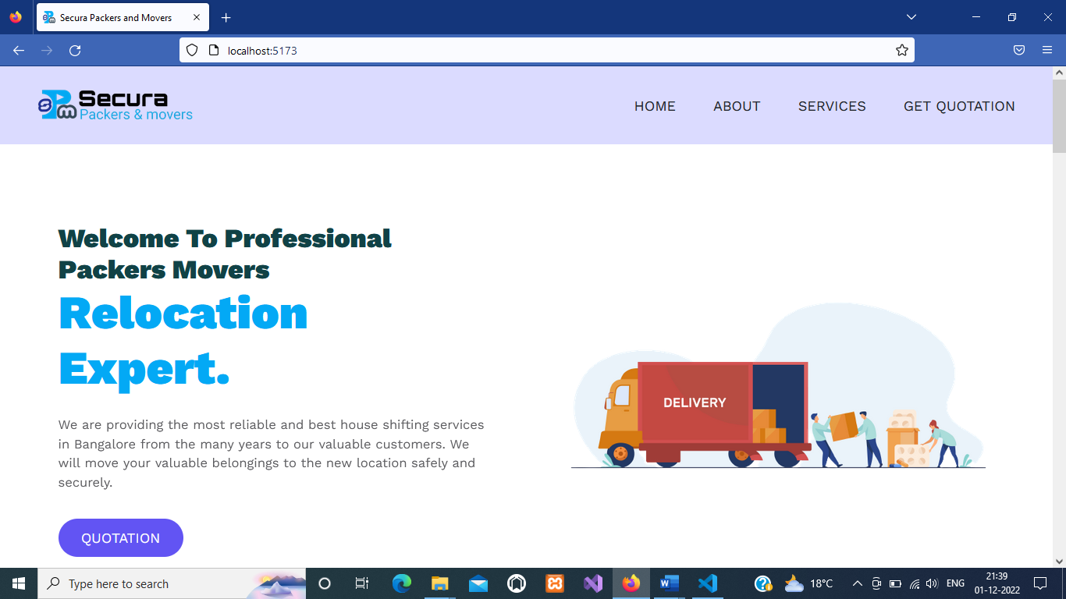

14.2 About Page

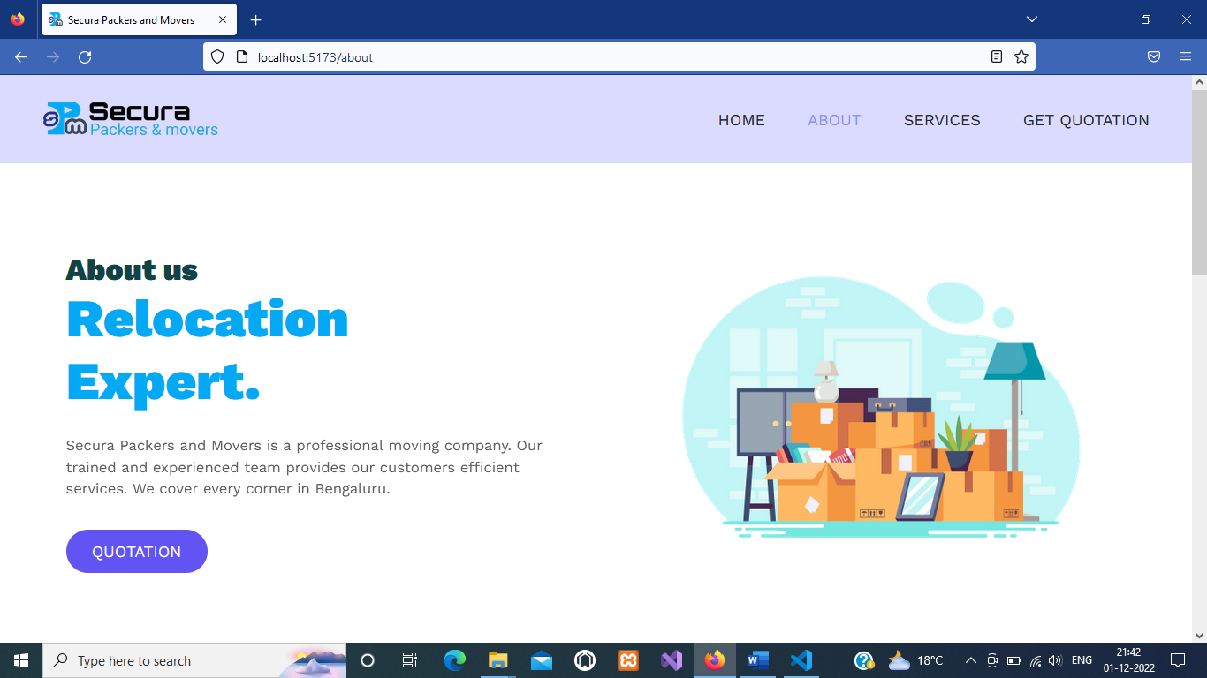

14.3 Services Page

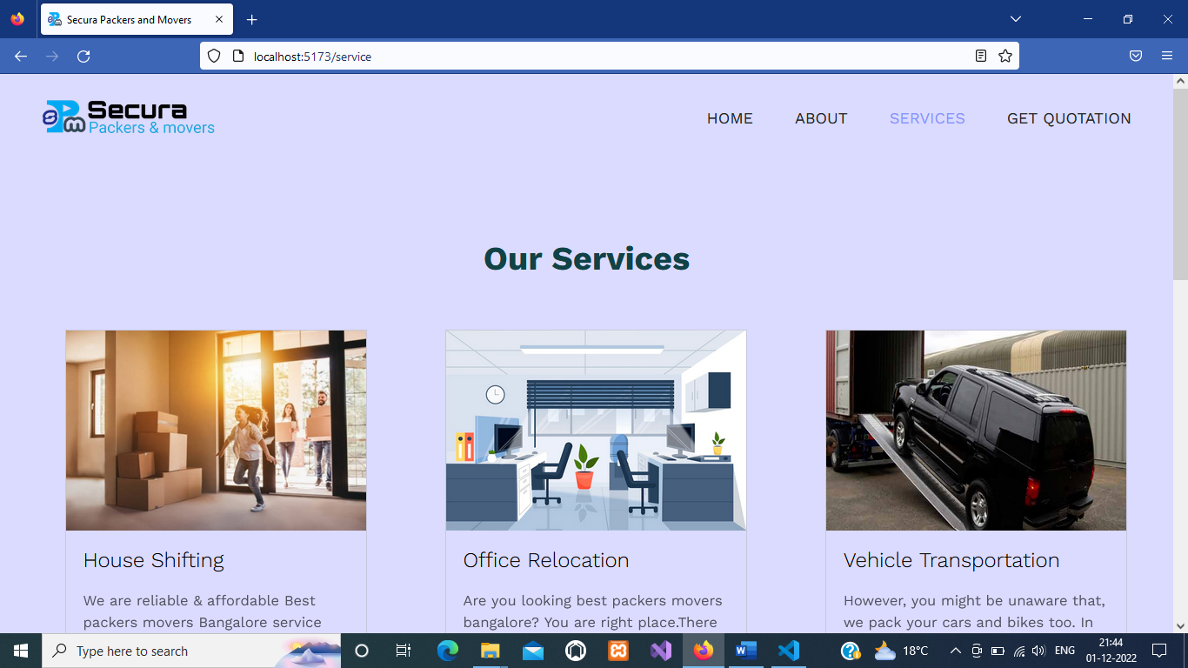

14.4 Get Quotation Page

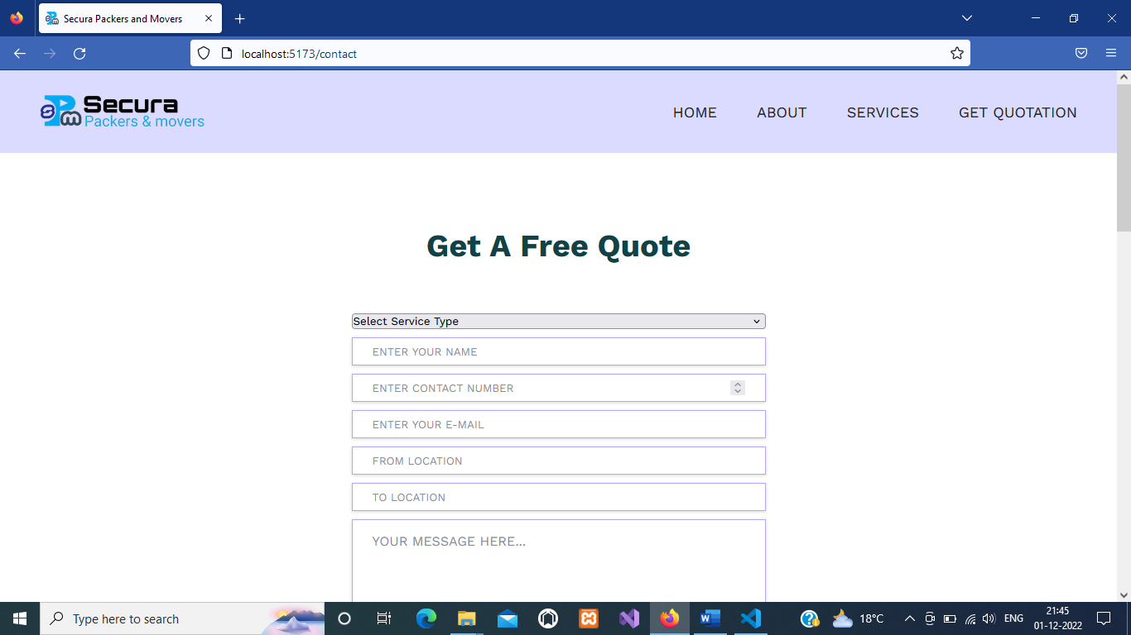

14.5 Error Page

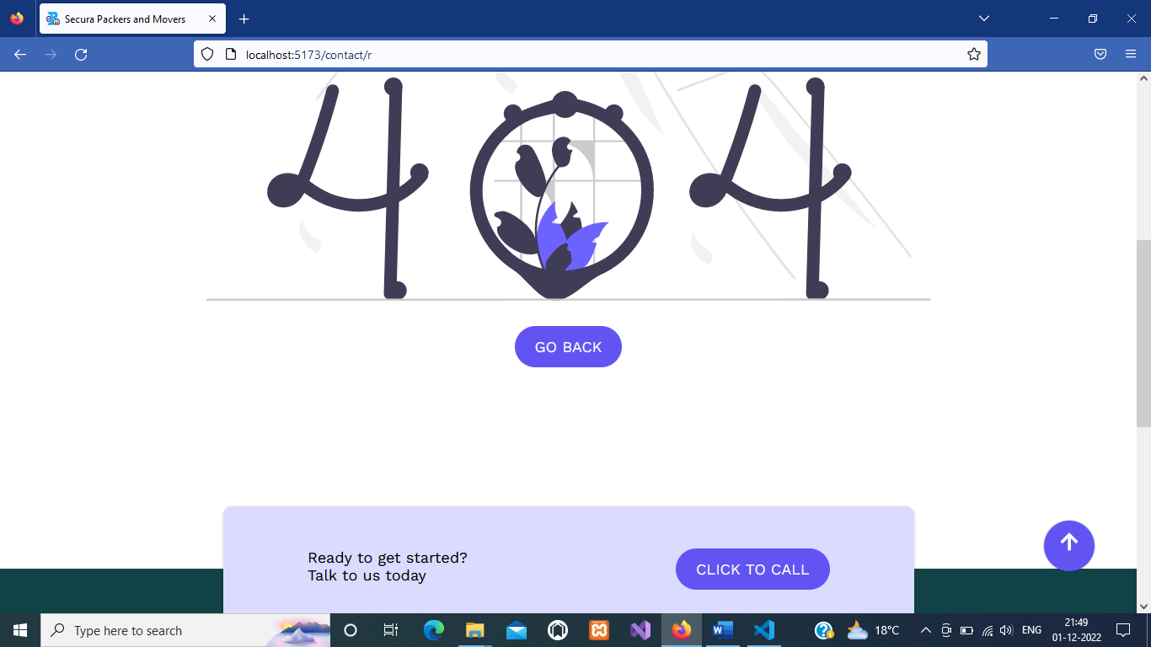

CHAPTER 15: CODING

index.html

<!DOCTYPE html>
<html lang="en">
<head>
<meta charset="UTF-8" />
<link rel="icon" type="image/svg+xml" href="/images/icon.png" />
<meta name="viewport" content="width=device-width, initial-scale=1.0" />
<title>Secura Packers and Movers</title>
<link rel="preconnect" href="https://fonts.gstatic.com" crossorigin />
<link
href="https://fonts.googleapis.com/css2?family=Lora:wght@400;500&family=Work+Sans:wght@300;400;700;900&display=swap"
rel="stylesheet"
/>
</head>
<body>
<div id="root"></div>
<script type="module" src="/src/main.jsx"></script>
</body>
</html>

main.jsx

import React from "react";
import ReactDOM from "react-dom/client";
import App from "./App";
import "./index.css";
import { AppProvider } from "./context";

ReactDOM.createRoot(document.getElementById("root")).render(
<React.StrictMode>
<AppProvider>
<App />
</AppProvider>
</React.StrictMode>
);

App.jsx

import About from "./About";
import Contact from "./Contact";
import Home from "./Home";
import Services from "./Services";
import { BrowserRouter, Routes, Route } from "react-router-dom";
import Header from "./components/Header";
import Footer from "./components/Footer";
import { ThemeProvider } from "styled-components";
import { GlobalStyle } from "./GlobalStyle";
import Error from "./Error";
import GoToTop from "./components/GoToTop";

const App = () => {
const theme = {
colors: {
heading: "#104246",
text: "rgb(24 24 29)",
white: "#fff",
black: " #212529",
helper: "#8490ff",
bg: "rgb(219, 219, 334)",
footer_bg: "#104246",

btn: "rgb(98 84 243)",
border: "rgba(98, 84, 243, 0.5)",
hr: "#ffffff",
gradient:
"linear-gradient(0deg, rgb(132 144 255) 0%, rgb(98 189 252) 100%)",
shadow:
"rgba(0, 0, 0, 0.02) 0px 1px 3px 0px,rgba(27, 31, 35, 0.15) 0px 0px 0px 1px;",
shadowSupport: " rgba(0, 0, 0, 0.16) 0px 1px 4px",
},
media: { mobile: "768px", tab: "998px" },
};

return (
<ThemeProvider theme={theme}>
<GlobalStyle />
<GoToTop />
<BrowserRouter>
<Header />
<Routes>
<Route path="/" element={<Home />} />
<Route path="/about" element={<About />} />
<Route path="/service" element={<Services />} />
<Route path="/contact" element={<Contact />} />
<Route path="*" element={<Error />} />
</Routes>

<Footer />
</BrowserRouter>
</ThemeProvider>
);
};

export default App;

Home.jsx

import { useEffect } from "react";
import HeroSection from "./components/HeroSection";
import { useGlobalContext } from "./context";
import Services from "./Services";
import Contact from "./Contact";
import AboutSection from "./components/AboutSection";

const Home = () => {
const { updateHomePage } = useGlobalContext();

useEffect(() => updateHomePage(), []);

return (
<>
<HeroSection />
<Services />
<AboutSection/>
<Contact />
</>
);
};

export default Home;

About.jsx

import React, { useEffect } from "react";
import HeroSection from "./components/HeroSection";
import { useGlobalContext } from "./context";
import styled from "styled-components";
import AboutSection from "./components/AboutSection";

const About = () => {
const { udpateAboutPage } = useGlobalContext();

useEffect(() => udpateAboutPage(), []);

return (
<Wrapper className="Section">
<HeroSection />
<AboutSection/>
</Wrapper>
);
};

const Wrapper = styled.section`

`;

export default About;

Services.jsx

import React from "react";
import styled from "styled-components";
import { useGlobalContext } from "./context";
import { NavLink } from "react-router-dom";
import { Button } from "./styles/Button";
import image from "/images/office-background-video.png";
import img2 from "/images/house-3-padsvm3utr07zgsdpgtw6tiww2nkybgf0dcqshv0kg.jpg"
import img3 from "/images/car-transportation-img.png"

const Services = () => {
const { services } = useGlobalContext();
console.log(services);

return (
<Wrapper className="section">
<h2 className="common-heading">Our Services</h2>
<div className="container grid grid-three-column">

<div className="card">
<figure>
<img src={img2} alt= "Sk"/>
</figure>
<div className="card-data">
<h3>House Shifting</h3>
<p>We are reliable & affordable Best packers movers Bangalore service providers, and you can trust on us without any hassle. We can deliver your goods by packing it with care and shift it to the right location within no time.</p>
<NavLink to="/service">
<Button className="btn">Read More</Button>
</NavLink>
</div>
</div>

<div className="card">
<figure>
<img src={image} alt= "Sk"/>
</figure>
<div className="card-data">
<h3>Office Relocation</h3>
<p>Are you looking best packers movers bangalore? You are right place.There is no need to take any tension if we are here. Our professional and skilled team workers pack and deliver all your things from your old office to a new office.</p>
<NavLink to="/service">
<Button className="btn">Read More</Button>
</NavLink>
</div>
</div>

<div className="card">
<figure>
<img src={img3} alt= "Sk"/>
</figure>
<div className="card-data">
<h3>Vehicle Transportation</h3>
<p>However, you might be unaware that, we pack your cars and bikes too. In addition to packing the vehicles; we ensure safe bike transport as well.</p>
<NavLink to="/service">
<Button className="btn">Read More</Button>
</NavLink>
</div>
</div>

</div>

</Wrapper>
);
};

const Wrapper = styled.section`
padding: 9rem 0;
background-color: ${({ theme }) => theme.colors.bg};

.container {
max-width: 120rem;
}

.card {
border: 0.1rem solid rgb(170 170 170 / 40%);
.card-data {
padding: 0 2rem;
}

h3 {
margin: 2rem 0;
font-weight: 300;
font-size: 2.4rem;
}
.btn {
margin: 2rem auto;
background-color: rgb(0 0 0 / 0%);
border: 0.1rem solid rgb(98 84 243);
display: flex;
justify-content: center;
align-items: center;
color: rgb(98 84 243);
font-size: 1.4rem;

&:hover {
background-color: rgb(98 84 243);
color: #fff;
}
}
}

figure {
width: auto;
display: flex;
justify-content: center;
align-items: center;
position: relative;
overflow: hidden;
transition: all 0.5s linear;
&::after {
content: "";
position: absolute;
top: 0;
left: 0;
width: 0%;
height: 100%;
background-color: rgba(0, 0, 0, 0.5);
transition: all 0.2s linear;
cursor: pointer;
}
&:hover::after {
width: 100%;
}
&:hover img {
transform: scale(1.2);
}
img {
max-width: 120rem;
margin-top: 0rem;
height: 23rem;
transition: all 0.2s linear;
}
}

@media (max-width: ${({ theme }) => theme.media.tab}) {
.grid-three-column {
grid-template-columns: 1fr 1fr;
}
}

@media (max-width: ${({ theme }) => theme.media.mobile}) {
.grid-two-column,
.grid-three-column {
grid-template-columns: 1fr;
}
}
`;

export default Services;

Contact.jsx

import React from "react";
import styled from "styled-components";

const Contact = () => {
const Wrapper = styled.section`
padding: 9rem 0 5rem 0;

.container {
margin-top: 6rem;
margin-bottom: 6rem;
text-align: center;

.contact-form {
max-width: 50rem;
margin: auto;

.contact-inputs {
display: flex;
flex-direction: column;
gap: 1rem;

.abc{

height:0rem;

input[type="submit"] {
cursor: pointer;
transition: all 0.2s;

&:hover {
background-color: ${({ theme }) => theme.colors.white};
border: 1px solid ${({ theme }) => theme.colors.btn};
color: ${({ theme }) => theme.colors.btn};
transform: scale(0.9);
}
}
}
}
}
}
`;

return (
<Wrapper>
<h2 className="common-heading">Get a Free Quote</h2>

<div className="container">
<div className="contact-form">
<form
action="https://formspree.io/f/xqkjoykn"
method="POST"
className="contact-inputs"
>
<select title="selectServices">
<option>Select Service Type</option>
<option>House Shifting</option>
<option>Office Shifting</option>
<option>Vehicle Shifting</option>
<option>Parcel Services</option>
<option>Only Packing</option>
</select>

<input className="abc"
type="text"
name="name"
placeholder="Enter Your Name"
autoComplete="off"
required
/>

<input className="abc"
type="number"
name="Number"
placeholder="Enter Contact Number"
autoComplete="off"
required
/>

<input className="abc"
type="email"
name="Email"
placeholder="Enter Your E-mail"
autoComplete="off"
required
/>

<input className="abc"
type="text"
name="From Location"
placeholder="From Location"
autoComplete="off"

/>

<input className="abc"
type="text"
name="To Location"
placeholder="To Location"
autoComplete="off"
required
/>

<textarea
name="message"
placeholder="Your Message Here..."
cols="30"
rows="5"
autoComplete="off"
required
></textarea>

<input type="submit" value="send" />
</form>
</div>
</div>

<iframe
src="https://www.google.com/maps/embed?pb=!1m14!1m8!1m3!1d15552.9910197238!2d77.5829988!3d12.955992!3m2!1i1024!2i768!4f13.1!3m3!1m2!1s0x0%3A0x7e867cf76de6ae30!2sSecura%20Packers%20And%20Movers!5e0!3m2!1sen!2sin!4v1669435017535!5m2!1sen!2sin"
width="100%"
height="450"
style={{ border: 0 }}
allowFullScreen=""
loading="lazy"
referrerPolicy="no-referrer-when-downgrade"
></iframe>
</Wrapper>
);
};

export default Contact;

CHAPTER 16: FUTURE SCOPE OF THE PROJECT

To develop this project, we had used very convenient, reliable library “React.js”. This library was built and is being maintained by tech-giant Facebook, and is very popular among the developer’s community. So, it is going to stay for a long time. This allows our website to stay functional for a long time. In this technology, it is easier to add further functionality since it is a component-based library. Usually in many places a lot of time and money is wasted in searching reliable and genuine service-provider. This platform will minimize these issues. With the help of this platform all the problems are sorted out.

- Further, user registration and login features can be introduced.
- In future CRM (customer relationship management) can be used along with this website for customer management.
CHAPTER 17: CONCLUSION

Today we are essentially operating in a global market. The successful enterprises in this fiercely competitive economy are those which can ensure a high level of customer satisfaction and at a considerably low cost. The focus today is not on meeting the customer’s expectations, but on exceeding them.

To achieve the objectives of this project i.e., building a platform, attracting the customers, and providing them the services they need. It is essential to have a well-defined organizational structure. This platform will provide the features to the users they need. All the services being offered have been mentioned properly.

These months have taught me a lot. I sincerely feel that the compulsion to do a project as a part of BCA III is very much justified, for it is not only useful and satisfaction to those who work with full dedication and concentration on it.
CHAPTER 18: REFERENCES

The resources referred during the development of this project are as follows-

- HTML , CSS from https://www.w3schools.com/

- React from https://www.simplilearn.com/

- JavaScript from https://developer.mozilla.org/

- Other Sources – YouTube.com, https://in.coursera.org/

